N8N Flow (Model Alone)
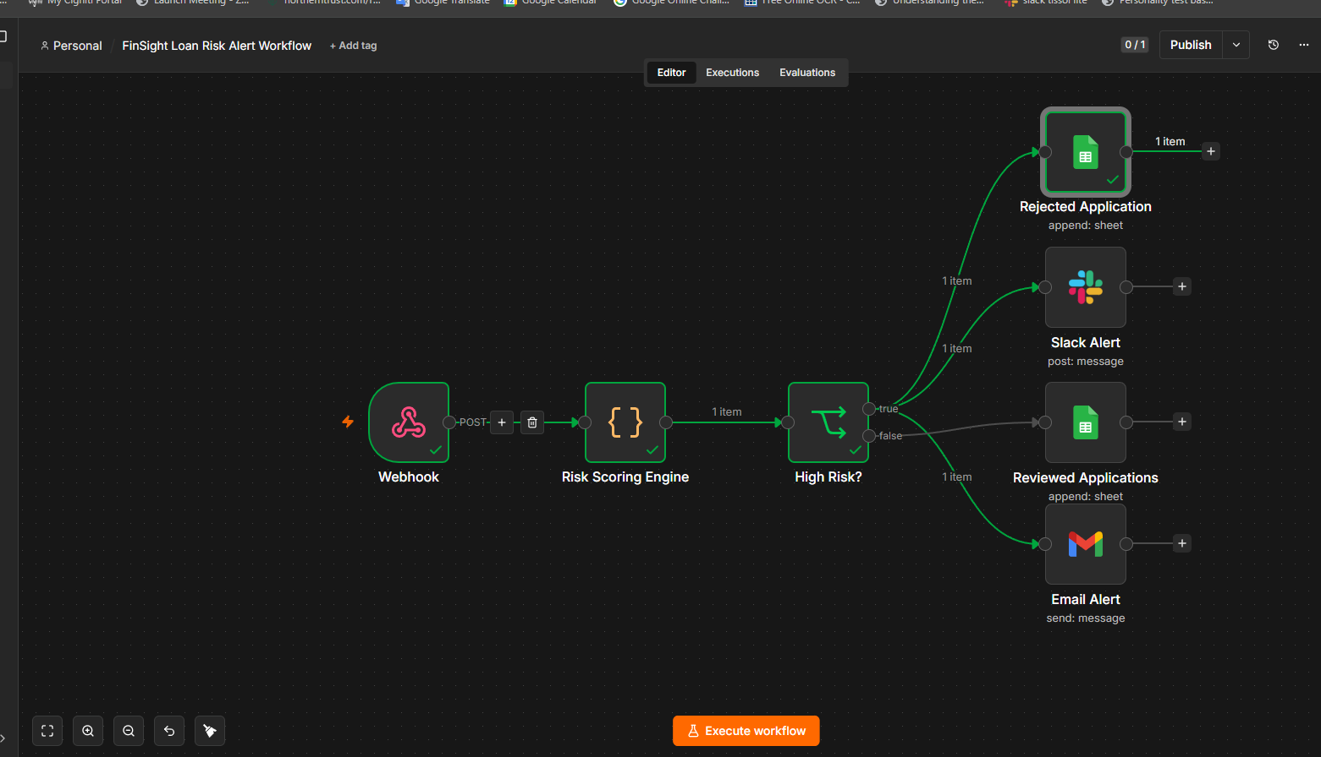

Rejected Applciation https://docs.google.com/spreadsheets/d/1FWsTGXiRnS88acgn_-quq9xbh2VSWfAv-wsO70A-g2Q/edit?gid=790178849#gid=790178849
To Be reviewed Application https://docs.google.com/spreadsheets/d/1FWsTGXiRnS88acgn_-quq9xbh2VSWfAv-wsO70A-g2Q/edit?gid=772848567#gid=772848567
FinSight Alert with models found default 110 accounts from 2k synthetic data -- > https://docs.google.com/spreadsheets/d/1FWsTGXiRnS88acgn_-quq9xbh2VSWfAv-wsO70A-g2Q/edit?gid=2026134753#gid=2026134753

Slack URL https://app.slack.com/client/T0BB2G8T7FS/C0BA885FX6W

FINSIGHT Project Folder -- > https://drive.google.com/drive/folders/1GU-LssGp77Y8crZCX9In9Y2MVn9rYCqB?usp=drive_link

Model With Langchain (Deployed using flask)
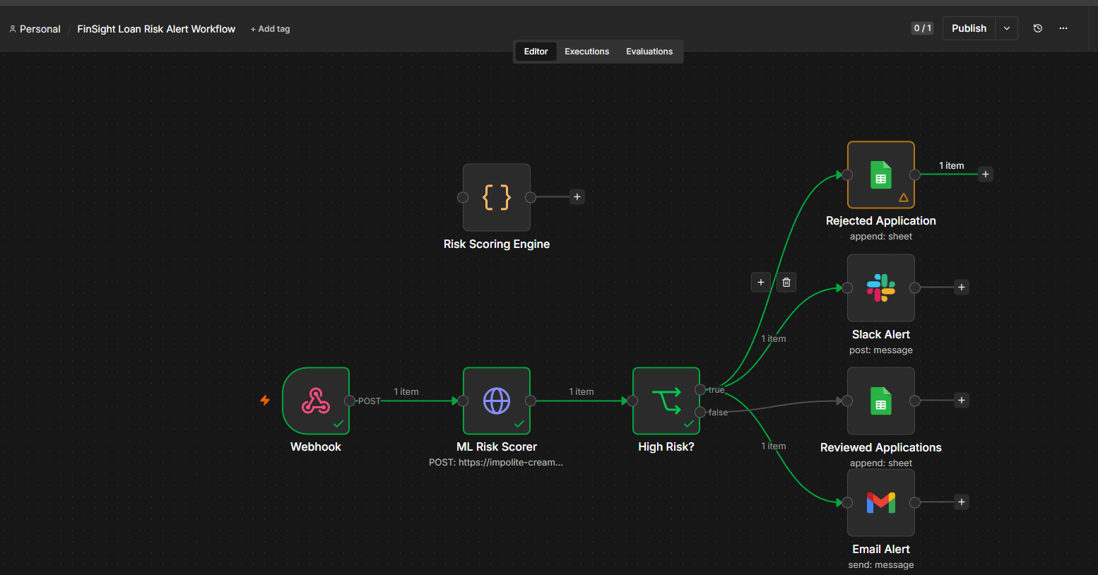

N8N Flow post:

